

INSTALLATION MANUAL

Table of Contents

Applicable Version………………..….……………………………….……………………….………3

Prerequisite..……………………………………………………….……………………………………….4

Installation....………………………….……….………………………………………………………….5

Configuring worldline……………………………………………………………………………………9

Applicable versions

- PHP

- PHP 5.3.x to 5.6.x

- Magento

- Magento 1.7.x to 1.9.x

Prerequisite

Make sure that following DLLs are enabled in PHP configuration file to work with worldline Payment Gateway:

extension = php_soap.dll
extension = php_openssl.dll
extension = php_curl.dll
extension= php_mcrypt.dll

Installation

Please follow the given steps to install and run the worldline Payment Gateway module

- First, you need to log in to the Magento administrator area.
  - Visit URL www.<mysite.com>/admin.
  - Enter Username and password.
- Then go to System -> Magento Connect -> Magento Connect Manager. 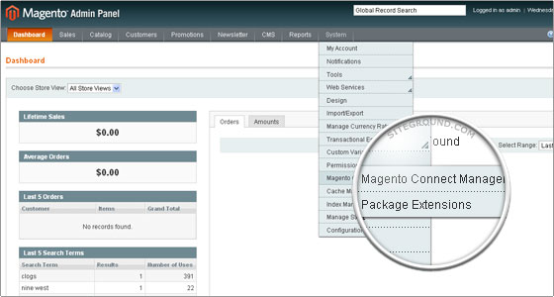
- A new page will open for the Magento Connect Manager and you will be asked to provide your administrative credentials again.
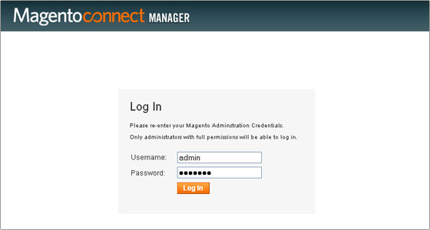

- Once logged in you will see 2 sections: Extensions and Settings. It is recommended to verify the options chosen in the Settings section first.
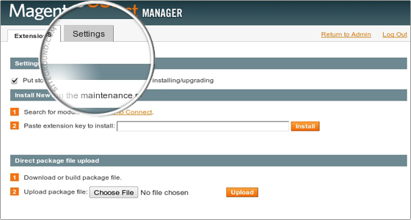

- In the Settings section you can configure options if you need to do. It is safe to leave those options to their default values.
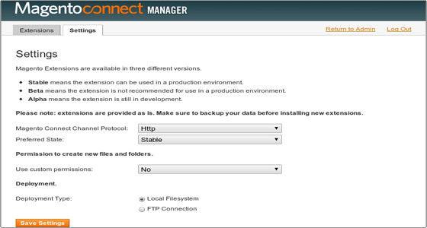
- Go to Extensions. In “Direct package file upload” tab click on “Browse” button to upload package file. Select worldline.tar file provided by worldline payment gateway module and click open. Now click “upload” to start uploading files.
- Wait until you get message as “Package Installed”. The Console Box displays the results of your install. If there are any issues, it will be displayed in this box. After the extension is properly installed a screen for a successful installation will appear:
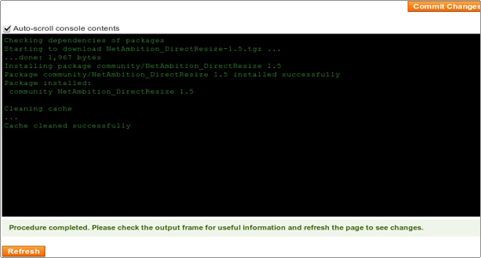

- Click refresh. Once the extension is installed it is important to go back to Magento admin (Click on Return to admin).
- worldline is now installed on your site.

Configuring worldline

- Go-to admin panel.
- Go-to menu System->Configuration.
- Select “Payment methods” under “Sales” tab on left panel.
- Click on worldline Payment Gateway.
- Configure it as below:
Column Name | Description
Enabled | “Yes” to enable and use, else “No” to disable worldline
Title | Title Text to display during checkout process
IV | Enter IV.
Key | Enter Key.
Merchant Code | Enter merchant code.
Request Type | Select “T” for transaction request type.
New order status | Select as “Processing”

- Now click on “Save Config” on top- right corner.
- worldline Payment Gateway is now configured & ready to use.

